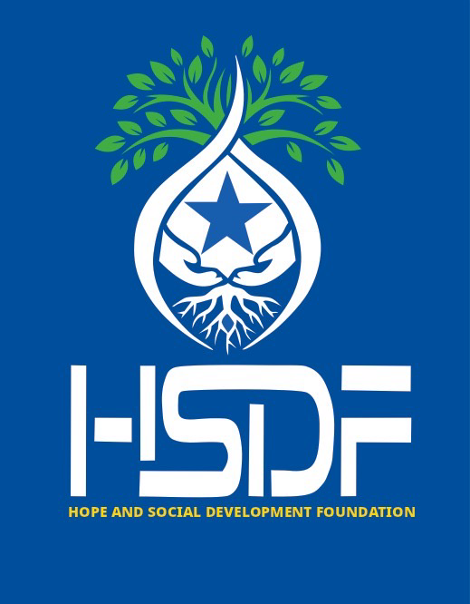
Hope and Social Development Foundation (HSDF)

Organization Profile

About Us
Hope and Social Development Foundation (HSDF) is a Somali-owned and Somali-led non-governmental organization committed to delivering life-saving humanitarian assistance and promoting sustainable development across Somalia. Founded on the principles of local ownership, community empowerment, and international solidarity, HSDF partners with vulnerable communities to address immediate humanitarian needs while strengthening long-term resilience and self-reliance.

Vision
A resilient Somalia where communities lead their own development, achieve self-reliance, and thrive despite conflict, climate extremes, and poverty.

Mission
HSDF works collaboratively with Somali communities to provide life-saving humanitarian support and foster sustainable development through locally led programs, inclusive approaches, and strategic international partnerships.
Core Values
- Local Ownership and Leadership • Equity and Inclusion
- Transparency and Accountability
- Sustainability and Resilience
- Collaboration and Partnerships
Main Objectives
- To provide timely, life-saving humanitarian assistance to vulnerable and crisis affected communities across Somalia.
- To improve access to inclusive, quality education and vocational skills that enhance youth and community self-reliance.
- To strengthen health and nutrition outcomes, particularly for women, children, and other at-risk groups.
- To enhance food security and household incomes through climate-resilient agriculture and sustainable livelihood opportunities.
- To expand equitable access to safe water, sanitation, and hygiene services through community-led solutions.
- To promote climate resilience, environmental protection, and sustainable natural resource management.
- To advance gender equality, protection, and social inclusion in all programs.
- To strengthen community capacity, local governance, and civic engagement for sustainable development.
Strategic Priority Areas

Education
Providing inclusive and quality education, vocational skills training, and life skills development while strengthening school management committees and community ownership of education systems.

Health and Nutrition
Improving access to essential health and nutrition services with a focus on maternal and child health, prevention and treatment of malnutrition, and rapid response to disease outbreaks.

Agriculture, Food Security, and Livelihoods
Enhancing food security and household incomes through climate-resilient agriculture, livestock and fisheries support, farmer cooperatives, savings and loan groups, and green livelihoods.

Water, Sanitation, and Hygiene (WASH)
Expanding sustainable access to safe water, sanitation, and hygiene services through community-managed and climate-smart WASH infrastructure.

Complementary Areas
Humanitarian Emergency Response, Climate Resilience and Environmental Protection, Protection and Gender Equality, Peacebuilding and Social Cohesion, Economic Empowerment, and Civic Engagement.

Cross-Cutting Approaches
- Gender Equality and Social Inclusion (GESI)
- Do No Harm and Conflict Sensitivity
- Community Accountability and Feedback Mechanisms
- Climate and Environmental Safeguards

Governance and Management
HSDF is governed by a Somali-majority Board of Directors and led by a Somali Executive Director. Over 90% of staff are national professionals with strong local knowledge and community networks, ensuring culturally appropriate, accountable, and effective programming.

Organizational Capacity and Experience
HSDF has demonstrated capacity in needs assessments, project design and implementation, coordination, monitoring, and reporting. The organization maintains strong partnerships with community leaders, district authorities, civil society actors, and humanitarian coordination mechanisms.
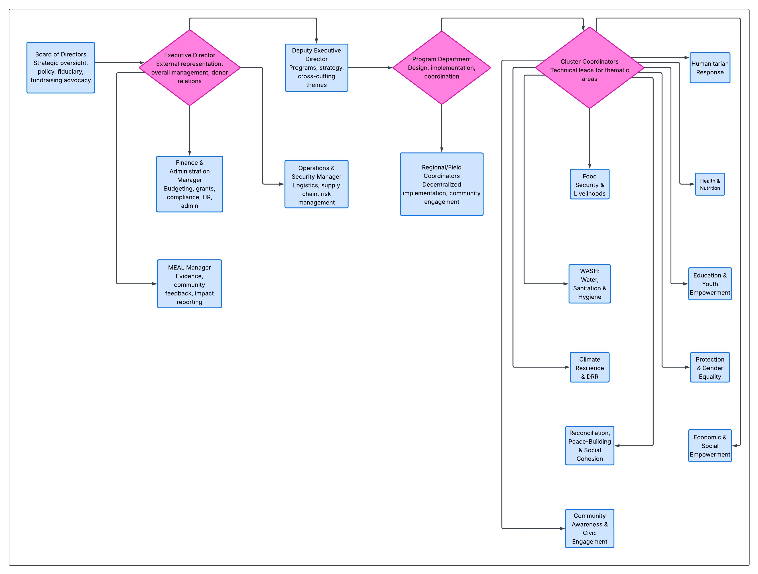
Figure 1: HSDF Organizational Structure

Monitoring, Evaluation, Accountability, and Learning (MEAL)
HSDF applies robust MEAL systems to ensure program quality, accountability, and continuous learning. Community feedback and complaint response mechanisms are integrated across all interventions.

Safeguarding and Compliance
HSDF maintains a zero-tolerance policy toward sexual exploitation and abuse (PSEA) and upholds child safeguarding standards, staff codes of conduct, and ethical compliance across all operations.

Sustainability and Exit Strategy
HSDF prioritizes capacity building, community ownership, and durable solutions. Clear exit strategies are embedded in program design to ensure long-term impact beyond project cycles.

Partnerships
HSDF partners with UN agencies, international NGOs, donors, diaspora networks, and private foundations. Through collaborative partnerships, HSDF leverages resources, shares knowledge, and coordinates efforts to maximize impact. The organization actively seeks multi-year and flexible funding arrangements to strengthen sustainable outcomes.

Why HSDF
HSDF’s strength lies in its deep community roots, Somali leadership, and ability to bridge humanitarian response with long-term development—ensuring communities are not only supported during crises but empowered to thrive.

